Q1_1

For this question, we should give inputs like this:

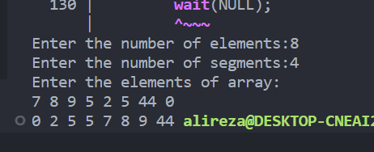

We should run it by this:

gcc q1.c -o q1

./q1

And at last it can be run like this :

Make part1

Q1_2

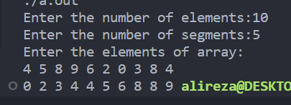

And at last it can be run like this :

Make part2

Q2_1

And at last it can be run like this :

Make server_1

Q2_2

And at last it can be run like this :

Make server_1

Q3_1

Just type **make**

Q3_2

Just type **make**